CTS WEEK 6: Module 10 – Single Page Application framework - React
EXERCISE-1
1. To create a new React app, Install Nodejs and Npm from the following link:
https://nodejs.org/en/download/
2. Install Create-react-app by running the following command in the command prompt:
3. To create a React Application with the name of “myfirstreact”, type the following command:
4. Once the App is created, navigate into the folder of myfirstreact by typing the following command:
5. Open the folder of myfirstreact in Visual Studio Code
6. Open the App.js file in Src Folder of myfirstreact
7. Remove the current content of “App.js”
8. Replace it with the following:
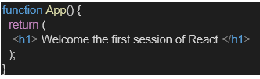
9. Run the following command to execute the React application:
10. Open a new browser window and type “localhost:3000” in the address bar
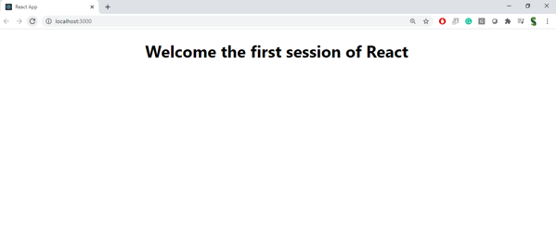

SOLUTION:
App.js
import React from 'react';
function App() {
return (
<div>
<h1>Welcome to the first session of React</h1>
</div>
);
}
export default App;
OUTPUT:
npm start
Go to: http://localhost:3000
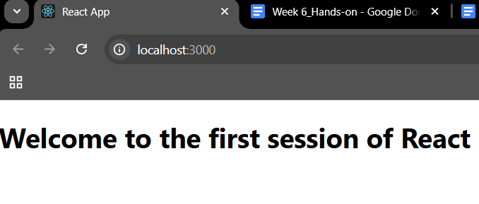

EXERCISE-2
Create a react app for Student Management Portal named StudentApp and create a component named Home which will display the Message “Welcome to the Home page of Student Management Portal”. Create another component named About and display the Message “Welcome to the About page of the Student Management Portal”. Create a third component named Contact and display the Message “Welcome to the Contact page of the Student Management Portal”. Call all the three components.
1. Create a React project named “StudentApp” type the following command in terminal of Visual studio:
2. Create a new folder under Src folder with the name “Components”. Add a new file named “Home.js”
3. Type the following code in Home.js
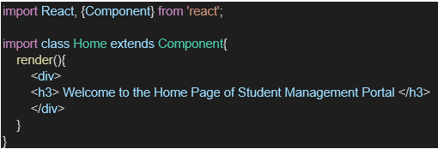
4. Under Src folder add another file named “About.js”
5. Repeat the same steps for Creating “About” and “Contact” component by adding a new file as ”About.js”, “Contact.js” under “Src” folder and edit the code as mentioned for “Home” Component.
6. Edit the App.js to invoke the Home, About and Contact component as follows:
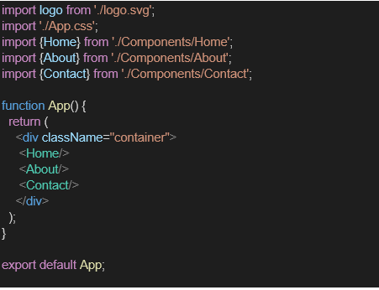

7. In command Prompt, navigate into StudentApp and execute the code by typing the following command:

8. Open browser and type “localhost:3000” in the address bar:

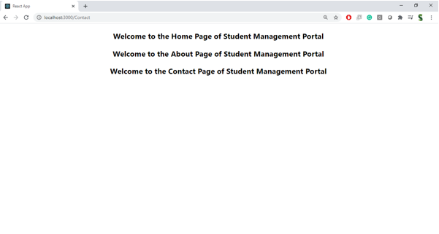
SOLUTION:

Create Home.js (Class Component)
import React, { Component } from 'react';
class Home extends Component {
constructor(props) {
super(props); }
render() {
return (
<div>
<h2>Welcome to the Home page of Student Management Portal</h2>
</div> ); }}
export default Home;

About.js
import React, { Component } from 'react';
class About extends Component {
render() {
return (
<div>
<h2>Welcome to the About page of the Student Management Portal</h2>
</div>
);
}
}
export default About;

Contact.js
import React, { Component } from 'react';
class Contact extends Component {
render() {
return (
<div>
<h2>Welcome to the Contact page of the Student Management Portal</h2>
</div>
);
}
}
export default Contact;

App.js
import React from 'react';
import Home from './Components/Home';
import About from './Components/About';
import Contact from './Components/Contact';
function App() {
return (
<div className="App">
<Home />
<About />
<Contact />
</div>
);
}
export default App;

OUTPUT:
Run the Application
npm start

Open in Browser
http://localhost:3000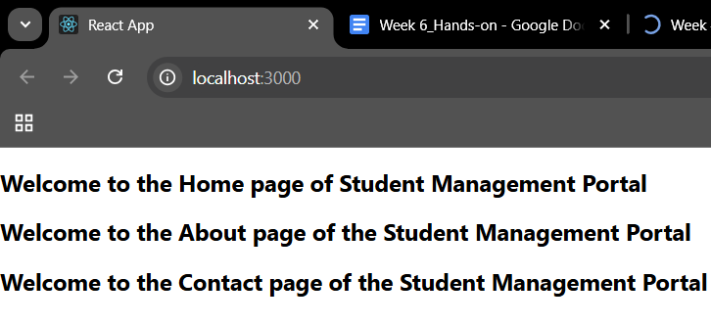
EXERCISE-3
1. Create a React project named “scorecalculatorapp” type the following command in terminal of Visual studio:
2. Create a new folder under Src folder with the name “Components”. Add a new file named “CalculateScore.js”
3. Type the following code in CalculateScore.js
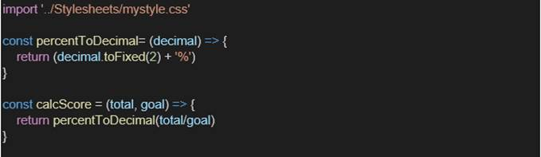
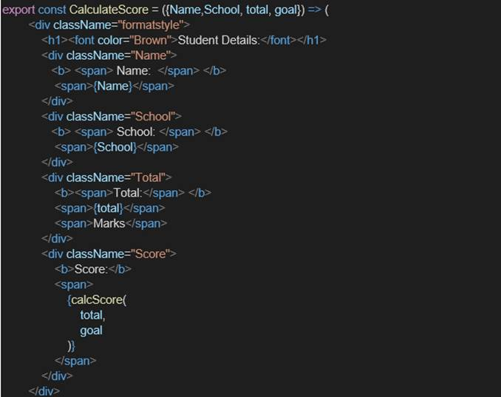

4. Create a Folder named Stylesheets and add a file named “mystyle.css” in order to add some styles to the components:
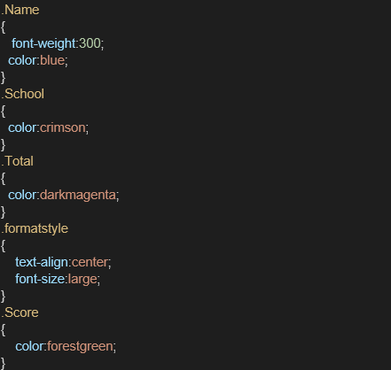

5. Edit the App.js to invoke the CalculateScore functional component as follows:

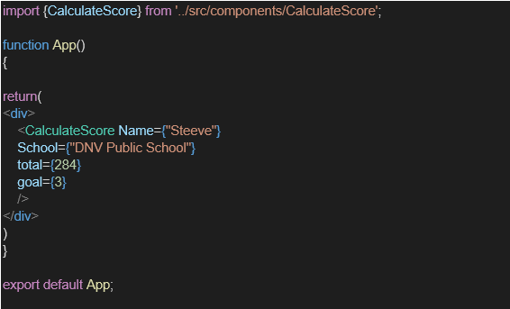
6. In command Prompt, navigate into scorecalculatorapp and execute the code by typing the following command:

7. Open browser and type “localhost:3000” in the address bar:

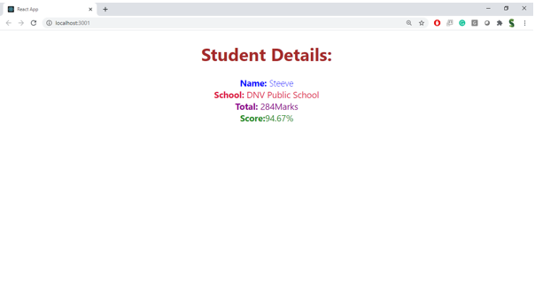
SOLUTION:
Cohorts.module.css
.container {
padding: 20px;
font-family: Arial, sans-serif;
}
.heading {
font-size: 24px;
font-weight: bold;
margin-bottom: 20px;}
.cardContainer {
display: flex;
gap: 20px;
}
.card {
border: 1px solid #ccc;
border-radius: 10px;
padding: 15px 25px;
width: 250px;
box-shadow: 2px 2px 5px rgba(0,0,0,0.1);
}
.blue {
color: blue;
font-weight: bold;
}
.green {
color: green;
font-weight: bold;
}
Cohorts.js
import React from 'react';
import styles from './Cohorts.module.css';
const data = [
{
id: "INTADMDF10 - .NET FSD",
color: "blue",
startDate: "22-Feb-2022",
status: "Scheduled",
coach: "Aathma",
trainer: "Jojo Jose"
},
{
id: "ADM21JF014 - Java FSD",
color: "green",
startDate: "10-Sep-2021",
status: "Ongoing",
coach: "Apoorv",
trainer: "Elisa Smith"
},
{
id: "CDBJF21025 - Java FSD",
color: "green",
startDate: "24-Dec-2021",
status: "Ongoing",
coach: "Aathma",
trainer: "John Doe"
}
];

export default function Cohorts() {
return (
<div className={styles.container}>
<div className={styles.heading}>Cohorts Details</div>
<div className={styles.cardContainer}>
{data.map((cohort, index) => (
<div key={index} className={styles.card}>
<div className={styles[cohort.color]}>{cohort.id}</div>
<p><strong>Started On</strong><br />{cohort.startDate}</p>
<p><strong>Current Status</strong><br />{cohort.status}</p>
<p><strong>Coach</strong><br />{cohort.coach}</p>
<p><strong>Trainer</strong><br />{cohort.trainer}</p>
</div>
))}
</div>
</div>
);
}

App.js
import React from 'react';
import Cohorts from './components/Cohorts';
function App() {
return (
<div>
<Cohorts />
</div>
);
}
export default App;
OUTPUT:
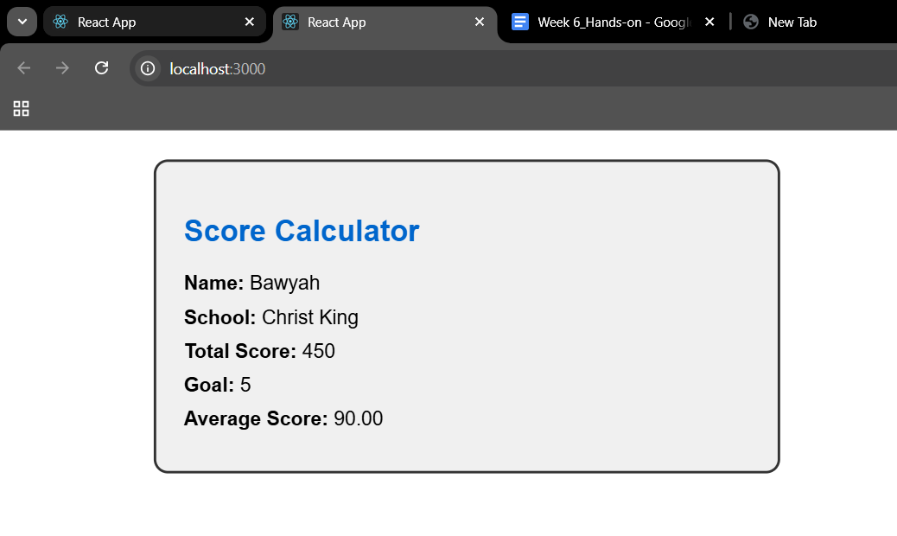
EXERCISE 4:
1. Create a new react application using create-react-app tool with the name as “blogapp”
2. Open the application using VS Code
3. Create a new file named as Post.js in src folder with following properties Figure 2: Post class
4. Create a new class based component named as Posts inside Posts.js file Figure 3: Posts Component
5. Initialize the component with a list of Post in state of the component using the constructor
6. Create a new method in component with the name as loadPosts() which will be responsible for using Fetch API and assign it to the component state created earlier. To get the posts use the url (https://jsonplaceholder.typicode.com/posts) Figure 4: loadPosts() method
7. Implement the componentDidMount() hook to make calls to loadPosts() which will fetch the posts Figure 5: componentDidMount() hook
8. Implement the render() which will display the title and post of posts in html page using heading and paragraphs respectively. Figure 6: render() method
9. Define a componentDidCatch() method which will be responsible for displaying any error happing in the component as alert messages.Figure 7: componentDidCatch() hook
10. Add the Posts component to App component.
11. Build and Run the application using npm start command.
SOLUTION:
src/Post.js
class Post {
constructor(id, title, body) {
this.id = id;
this.title = title;
this.body = body;
}
}
export default Post;
Posts.js
import React from 'react';
import Post from './Post';

class Posts extends React.Component {
constructor(props) {
super(props);
this.state = {
posts: [],
error: null
};
}
loadPosts = () => {
fetch("https://jsonplaceholder.typicode.com/posts")
.then((res) => res.json())
.then((data) => {
const postObjects = data.map(p => new Post(p.id, p.title, p.body));
this.setState({ posts: postObjects });
})
.catch((err) => {
this.setState({ error: err });
});
};
componentDidMount() {
this.loadPosts();
}
componentDidCatch(error, info) {
alert("Something went wrong: " + error); }

render() {
const { posts, error } = this.state;
if (error) {
return <h2>Error loading posts.</h2>;
}
return (
<div>
<h1>Blog Posts</h1>
{posts.map(post => (
<div key={post.id}>
<h3>{post.title}</h3>
<p>{post.body}</p>
<hr />
</div>
))}
</div>
);
}
}
export default Posts;
App.js
import React from 'react';
import Posts from './Posts';

function App() {
return (
<div className="App">
<Posts />
</div>
);
}
export default App;
OUTPUT:
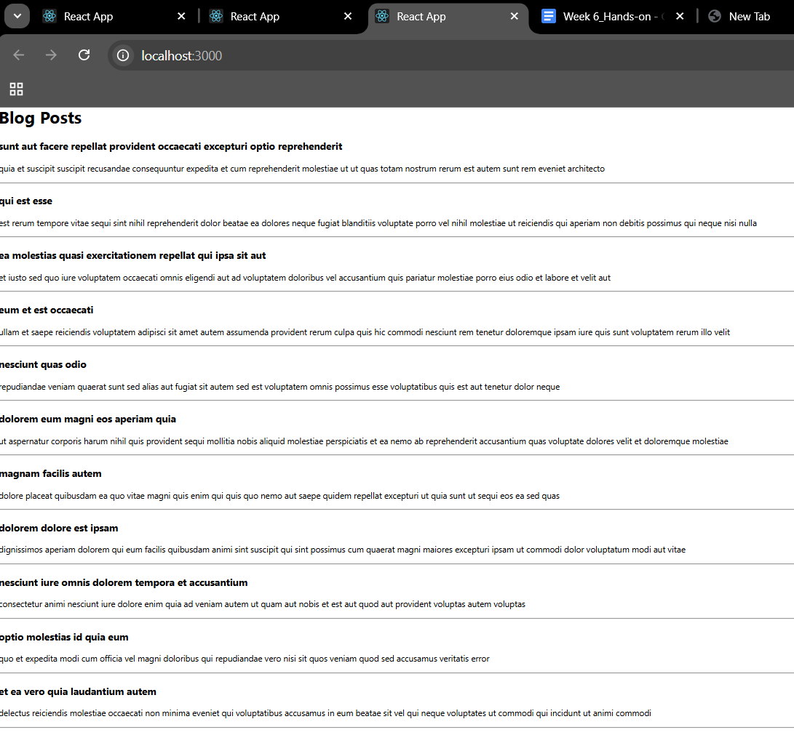
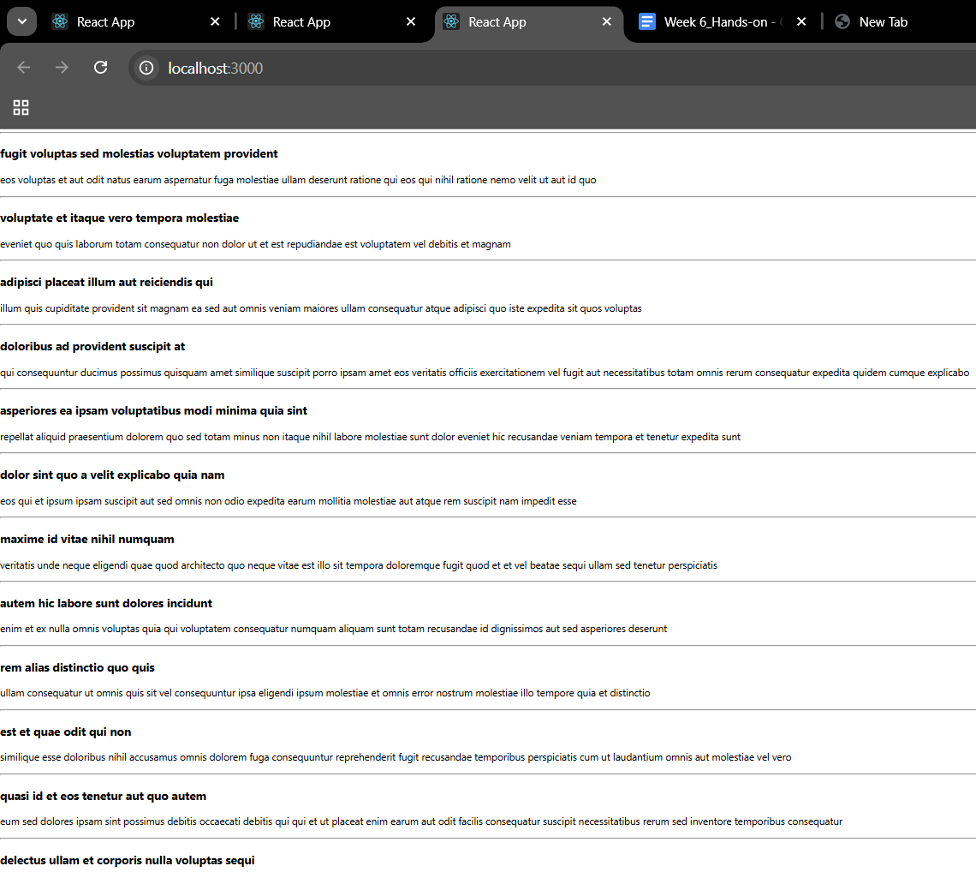

EXERCISE-5
My Academy team at Cognizant want to create a dashboard containing the details of ongoing and completed cohorts. A react application is created which displays the detail of the cohorts using react component. You are assigned the task of styling these react components.
Download and build the attached react application.
1. Unzip the react application in a folder
2. Open command prompt and switch to the react application folder
3. Restore the node packages using the following commands Figure 1: Restore packages
4. Open the application using VS Code
5. Create a new CSS Module in a file called “CohortDetails.module.css”
6. Define a css class with the name as “box” with following properties
Width = 300px;
Display = inline block;
Overall 10px margin
Top and bottom padding as 10px
Left and right padding as 20px
1 px border in black color
A border radius of 10px
7. Define a css style for html <dt> element using tag selector. Set the font weight to 500.
8. Open the cohort details component and import the CSS Module
9. Apply the box class to the container div
10. Define the style for <h3> element to use “green” color font when cohort status is “ongoing” and “blue” color in all other scenarios.
11. Final result should look similar to the b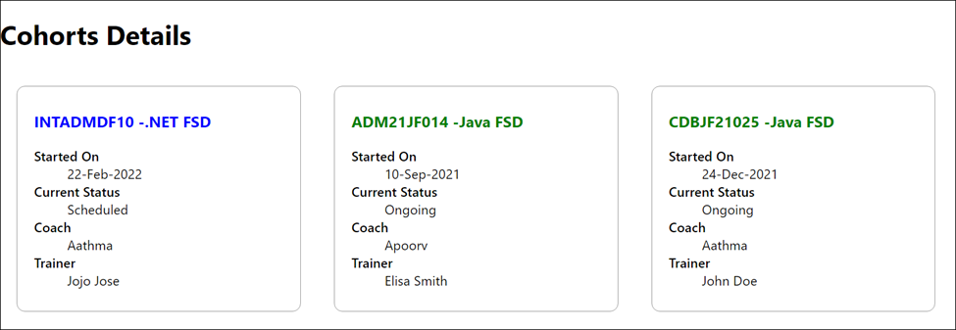
Figure 2: Final Result
SOLUTION:
src/components/CohortDetails.module.css
.box {
width: 300px;
display: inline-block;
margin: 10px;
padding: 10px 20px;
border: 1px solid black;
border-radius: 10px;
}
dt {
font-weight: 500;
}
src/components/CohortDetails.js
import React from 'react';
import styles from './CohortDetails.module.css';

const CohortDetails = ({ cohort }) => {
const titleStyle = {
color: cohort.status.toLowerCase() === 'ongoing' ? 'green' : 'blue',
};
return (
<div className={styles.box}>
<h3 style={titleStyle}>{cohort.name}</h3>
<dl>
<dt>Started On</dt>
<dd>{cohort.startDate}</dd>
<dt>Current Status</dt>
<dd>{cohort.status}</dd>
<dt>Coach</dt>
<dd>{cohort.coach}</dd>
<dt>Trainer</dt>
<dd>{cohort.trainer}</dd>
</dl>
</div>
);
};
export default CohortDetails;

src/App.js
import React from 'react';
import CohortDetails from './components/CohortDetails';
function App() {
const cohorts = [
{
name: 'INTADMDF10 -.NET FSD',
startDate: '22-Feb-2022',
status: 'Scheduled',
coach: 'Aathma',
trainer: 'Jojo Jose',
},
{
name: 'ADM21JF014 -Java FSD',
startDate: '10-Sep-2021',
status: 'Ongoing',
coach: 'Apoorv',
trainer: 'Elisa Smith',
},
{
name: 'CDBJF21025 -Java FSD',
startDate: '24-Dec-2021',
status: 'Ongoing',
coach: 'Aathma',
trainer: 'John Doe',
},
];

return (
<div>
<h1>Cohorts Details</h1>
{cohorts.map((cohort, index) => (
<CohortDetails key={index} cohort={cohort} />
))}
</div>
);
}

export default App;

OUTPUT:
